MAIN PAGE
uPVC (Vinyl) SIDING & SOFFIT
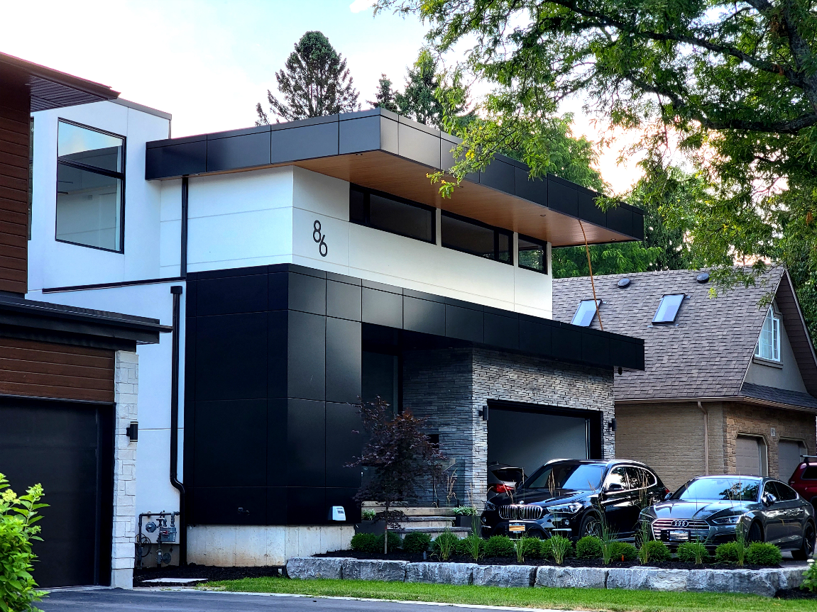
Industrial / Residential / Commercial / Agricultural
Designed in Canada. Built for Every Surface
uPVC vinyl siding offers the perfect blend of cost-effectiveness, durability, and aesthetic appeal, making it a preferred choice for homeowners and builders. Engineered to withstand fading, exceptional impact resistance, ensuring durability in various conditions. It minimizes heat buildup, repels water absorption, and remains impervious to bacteria and mold, making it a long-lasting, low-maintenance solution for a wide range of applications with a fresh, polished look and minimal upkeep.
Available in a variety of colors, textures, and profiles, vinyl siding allows for versatile design options to match any architectural style. Its lightweight construction ensures quick and easy installation, providing a high-performance, long-lasting solution for both renovations and new builds.

Architectural Cladding for Every Surface, Inside and Out
Transform your space with CladCan’s versatile uPVC panel systems engineered for walls, soffits, ceilings, beams, and columns. Whether you’re drawn to the crisp lines of V-Groove, the depth of U-Channel, or the bold elegance of the Shadow Series, our durable, low-maintenance profiles offer realistic wood or metal looks for any residential, commercial, or industrial application, indoors or outdoors.

PREMIUM SOFFIT PANELS- ICON
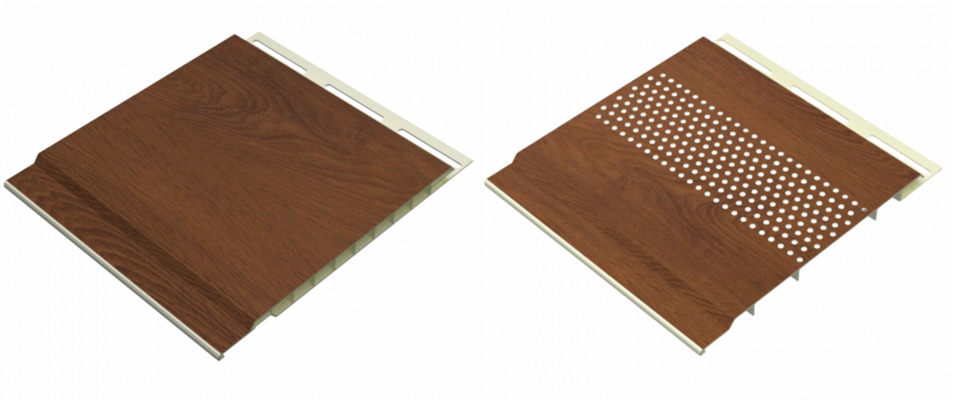
Complete the Look, Function Meets Design
Enhance the beauty and performance of any exterior with Cladcan-style soffit systems, crafted to deliver a clean, finished look across a wide range of applications—from residential entrances and patios to commercial overhangs and multi-family developments....... (Learn More / Expand)

PREMIUM SOFFIT PANELS (EXPANDED)
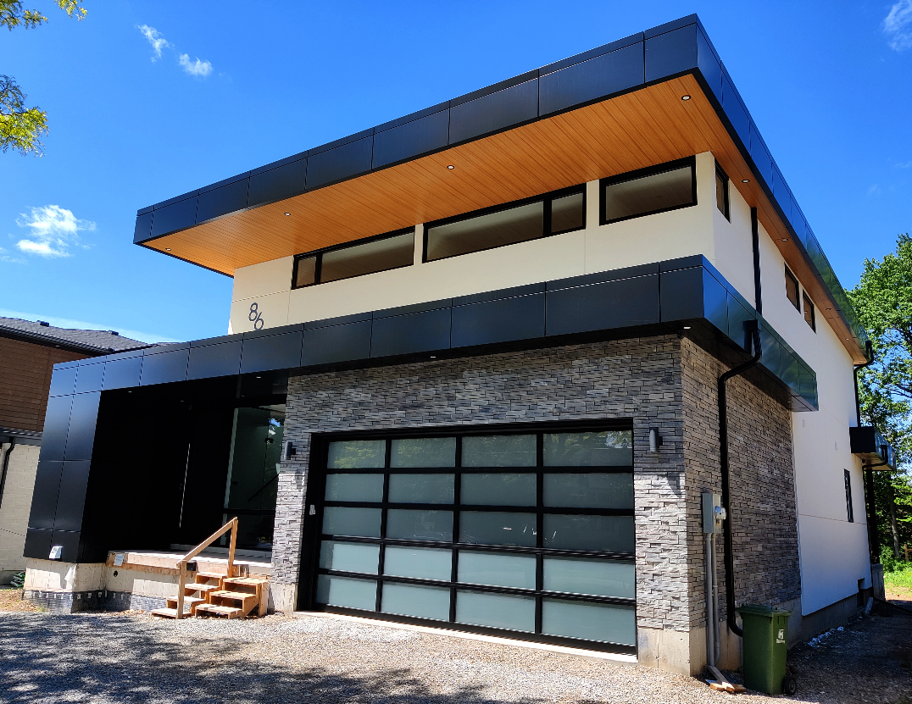
Expanded … Complete the Look, Function Meets Design
Enhance the beauty and performance of any exterior with Cladcan-style soffit systems, crafted to deliver a clean, finished look across a wide range of applications—from residential entrances and patios to commercial overhangs and multi-family developments
Our soffit panels are available in solid and fully vented formats, designed to integrate seamlessly for a uniform appearance while ensuring proper ventilation to protect your building envelope.

Smart Ventilation, Lasting Protection
Properly vented soffit is essential for moisture management, condensation control, and year-round airflow, reducing the risk of mold, mildew, and rot—issues that can lead to costly repairs and health hazards. Our fully perforated 4” and 6” vented panels align flawlessly with their solid counterparts to provide a hidden, streamlined venting solution that doesn’t compromise aesthetics.

Flexible, Durable & Built to Impress
Our Solid Flexible Soffit Panels (available in 4” and 6” widths) are specially engineered for curved walls, barrel ceilings, and radius applications, offering design freedom not commonly found in traditional soffit systems.

Product Highlights:
• Available in 4”, 6”, and 12” widths (solid, vented, or flexible options)
• Classic V-Groove and U-Channel profiles
• 12” seamless panel available for large-span applications (vent strip supplied separately)
• Made from durable, UV-stable uPVC—won’t fade, crack, or warp
• Designed for horizontal or overhead installations
• Low-maintenance and eco-friendly, made with recycled materials
• Wide selection of woodgrain, solid colour, anodized, and metallic finishes
• Seamlessly complements Cladcan wall cladding and architectural wraps

Whether you’re finishing a modern home, commercial storefront, or curved interior ceiling, Cladcan’s soffit systems provide a sustainable, low-maintenance alternative to wood or aluminum—engineered for long-term beauty and reliable protection.

Profile Details:

4” Soffit Panel
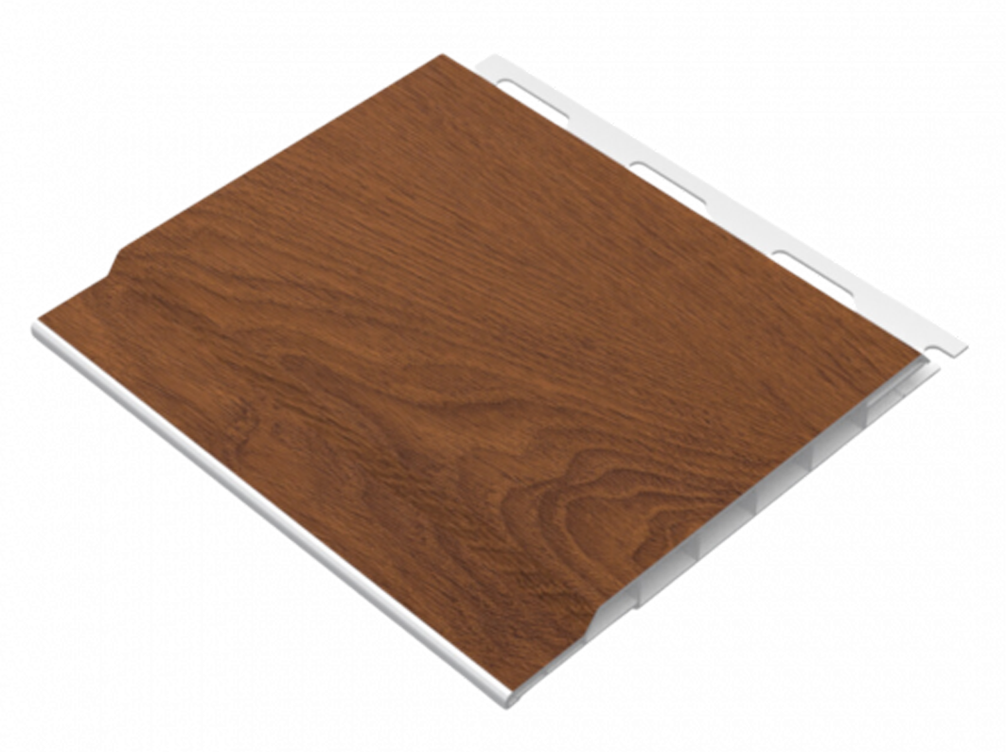

Material: Rigid PVC
Available Lengths: 12 ft and 20 ft
Profile Dimensions: 4” wide × 0.5” thick

6” Soffit Panel
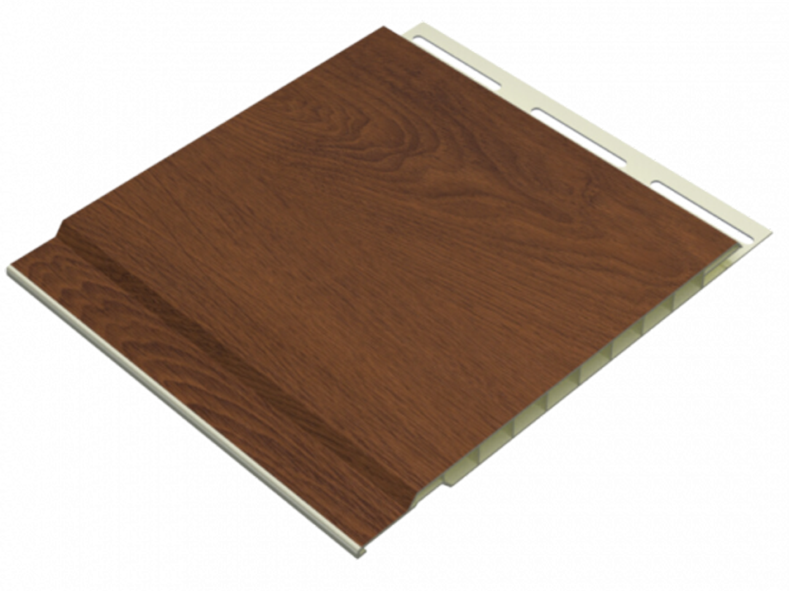

Material: Rigid PVC
Available Lengths: 12 ft, 16 ft, 20 ft and 30’, Custom Lengths Available
Profile Dimensions: 6” wide × 0.5” thick

4” Vented Soffit Panel
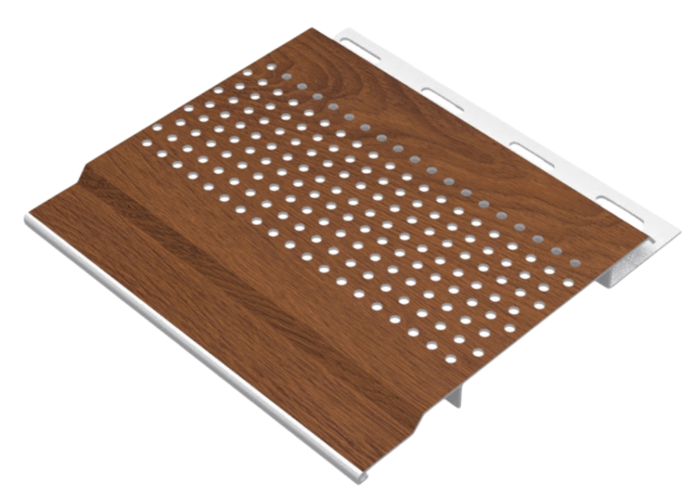

Material: Rigid PVC
Available Lengths: 12 ft, and 20 ft
Profile Dimensions: 4” wide × 0.5” thick

6” Vented Soffit Panel
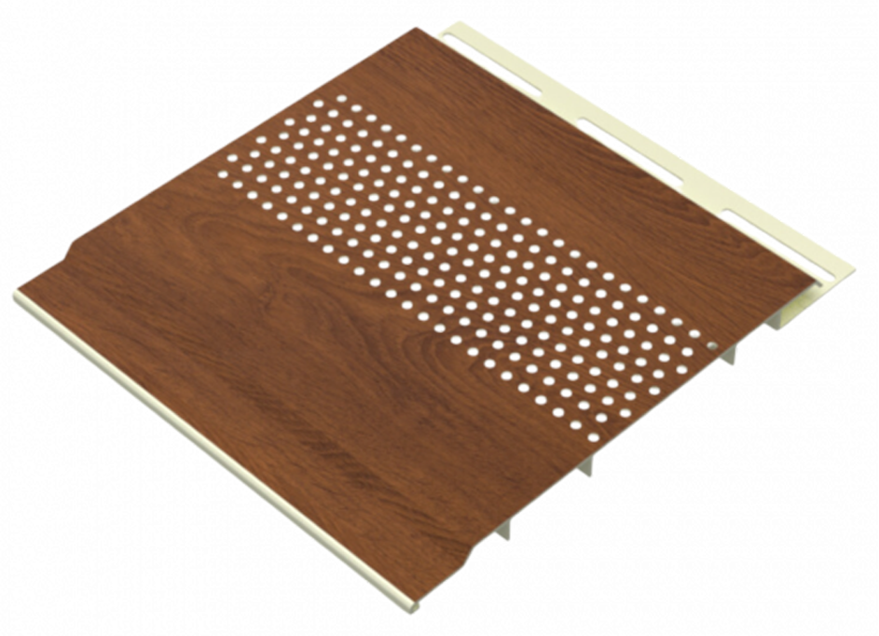

Material: Rigid PVC
Available Lengths: 12 ft, 16ft and 20 ft
Profile Dimensions: 6” wide × 0.5” thick

Trims
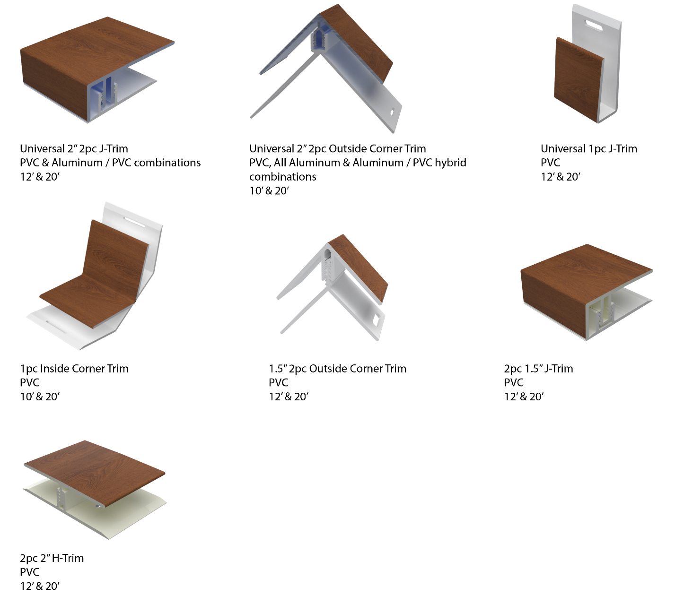

Stunning Finishes That Look and Feel Real
Authentic Textures. Lasting Performance. Designed to Impress.
Our extensive lineup includes rich woodgrains, sleek anodized looks, bold solid tones, metallic sheens, and elegant interior-specific finishes—each developed to meet a wide range of design needs.
Crafted using advanced film technology, many of our finishes feature a high-performance polyvinylidene fluoride (PVDF) top layer. This ensures long-term durability, superior UV resistance, and exceptional colour stability in all environments.
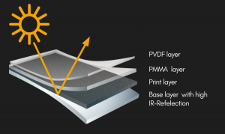
What sets these finishes apart:
- Heat-reflective technology for cooler surfaces and longer lifespan
- Embossed textures that simulate the natural feel of wood and other materials
- High pattern variation to avoid repetition and create a more organic look
- Matte and textured options for modern, high-end aesthetics

Whether you’re designing a modern exterior or an elegant interior feature, CladCan delivers finishes that look as good as they perform.

Looking for something specific?
Get in touch for our full catalogue of available finishes and custom options.

Woodgrain Finishes
4” & 6” Soffit Panels

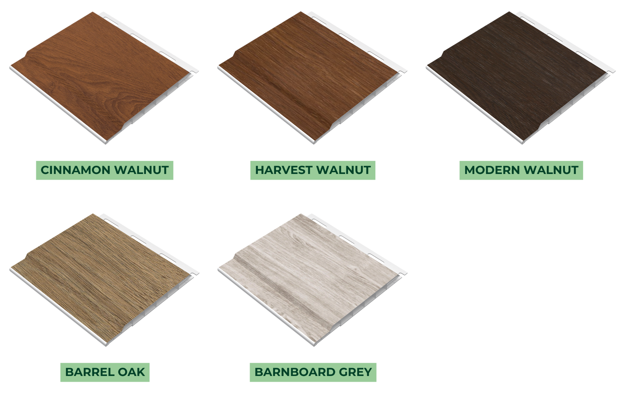

Woodgrain Finishes
4” Vented Soffit Panels

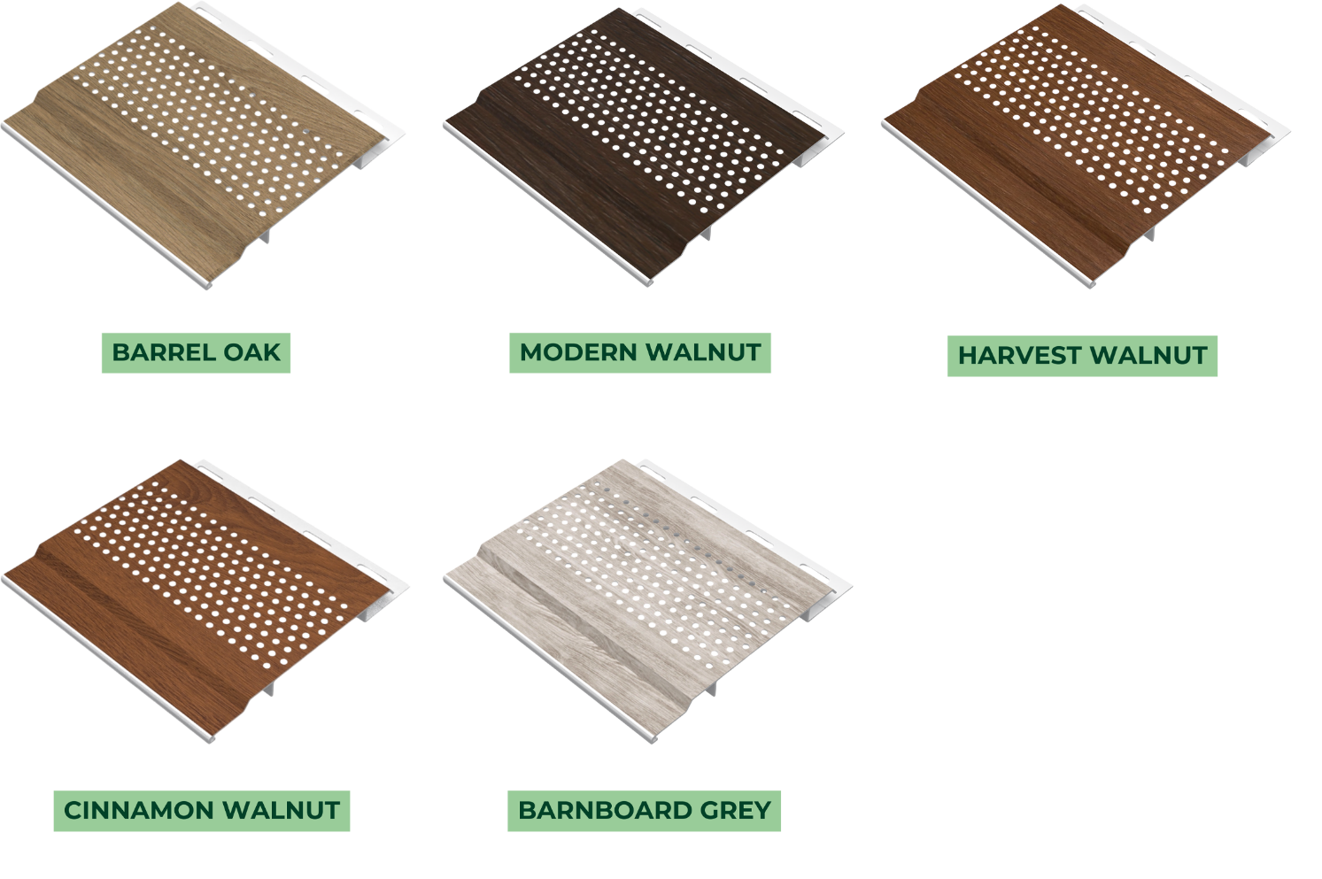

Woodgrain Finishes
6” Vented Soffit Panels

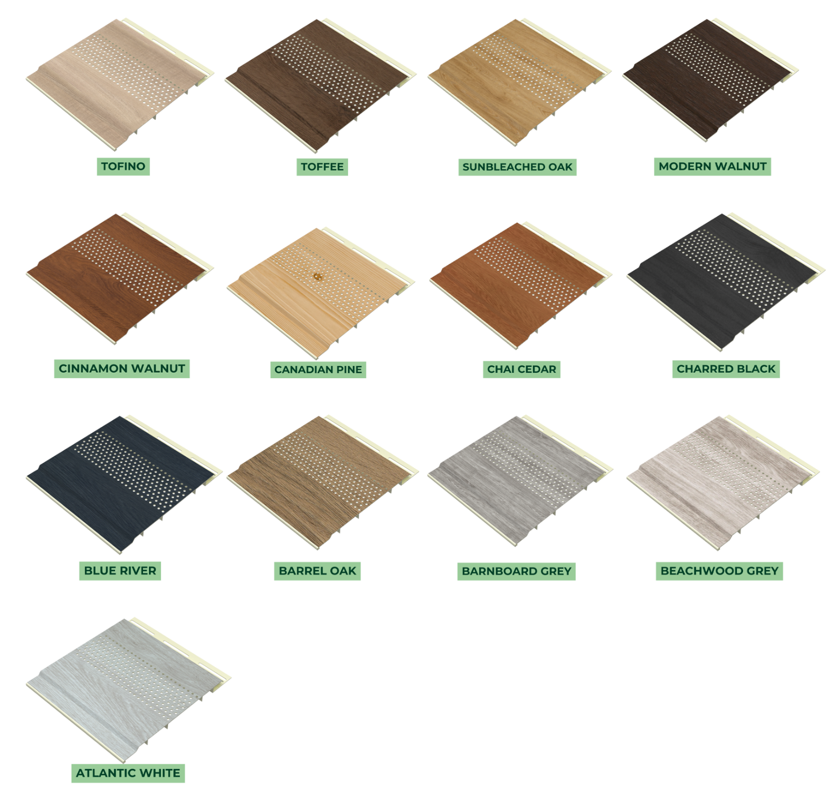

Solid Finishes
6” Vented Soffit Panels

